**ET.PM3 – PROJECT MANAGEMENT (SW3)**

**1 High Level Planning**

1. Think beyond your first approach idea. Explore thinking small and explore thinking big.
2. Fill in the blank part of the sentence below to help understand the actual completion point of your project.

|  |
| --- |
| *This project will be completed successfully when…*  … *is done.* |

**2 Project Flexibility Profile**

|  |  |  |  |
| --- | --- | --- | --- |
| Mark the level of flexibility for each constraint | **Inflexible, rigid** | **adaptable, negotiable** | **flexible** |
| **SCOPE/QUALITY** |  |  |  |
| **COSTS** |  |  |  |
| **SCHEDULE/TIME** |  |  |  |

**3 Reading: “Project Planning Pitfalls You Should Be Aware of”**

June 2018 (adapted from *actitime.com*)

Planning in general is an art and the same goes for [project planning](https://www.actitime.com/productivity-tools/free-project-management-software). But learning it requires time and effort, and on any step of a project manager’s career errors are possible. In this article, we’ll go through frequent project planning pitfalls you might experience in your career and provide some practical tips on how to prevent each so you can reduce project risk, meet your budget and make the client happy.

**1. Wrong Estimates**

The first major mistake you can make as a project manager is to have wrong estimates. That will ultimately lead to wasting time and not having enough resources. In fact, it’s proven that estimates that aren’t correct will result in project failure. Take your time when estimating. Know that if you do this right even if it costs you more time and effort, you’ll reap the benefits along the process of completing the project.

**2. Not Defining a Project Scope Early on**

Aside from defining it wrong, another big mistake you might make is to skip writing the project scope as soon as possible. However, the project scope must be defined clearly and should involve the stakeholders. You should write down the project scope statement and include the requirements and objectives. That must then be approved by the stakeholders to make sure everyone’s on the same page.

**3. Not Understanding the Project Requirements**

Each project has different requirements. Carefully studying them in advance ensures you plan accordingly and never miss an important detail that can cost you a lot in the long-run. Some project managers tend to rush through this process. Maybe it’s lack of experience or having too much on your plate. Whatever the case, you should make it a practice to not just go through the requirements for every next project even if they sound familiar, but to get feedback from superiors and colleagues before you create accurate estimates and begin assigning tasks.

**4. Setting an Unrealistic Deadline**

You also take a big risk when setting an unrealistic deadline. Unfortunately, that’s something we see quite often in the field of project management. Not giving your employees enough time to take each step and not leaving room for unexpected issues or delays means bigger mistakes can happen due to being in a hurry. The worst thing is that team members aren’t likely to share they need to slow down due to peer pressure unless everyone on the team is ready to admit it. It’s your job as a project manager to allocate just the right amount of time so that anyone can feel at ease while allowing the power of a fixed deadline to keep them on track.

**5. Not Identifying the Limitations**

Expectations are yet another thing that must be managed throughout the work process in a project. However, if these aren’t discussed early on, there might be communication issues that will cost time. You need to identify what won’t be done and consider it as important as the things that will be completed to achieve the end result. While writing the project scope, make sure to include the activities and responsibilities that you and your team won’t focus on.

**6. Not Monitoring the Work Progress**

While monitoring the work done each day and how employees perform is something almost any company is doing these days, many project managers fail to track work progress. This metric is key because it allows you and your team to stay accountable and to be as productive as possible. The first thing workers need in order to commit to their role and follow the guidelines provided is accurate data that shows how things are going and what’s left to be done. This has been shown to improve communication too, which is a vital aspect of successful project delivery.

**4 Gantt Charts**

Gantt charts tend to be the favorite schedule view for many senior executives. They are easy to comprehend and can show the completed work (usually indicated by showing a line through the bar). The disadvantage of a Gantt chart, as compared to a network diagram, can be the difficulty in seeing the critical path, dependency relationships, and slack time. However, this information may be of more importance to the project manager than the executive level sponsors.

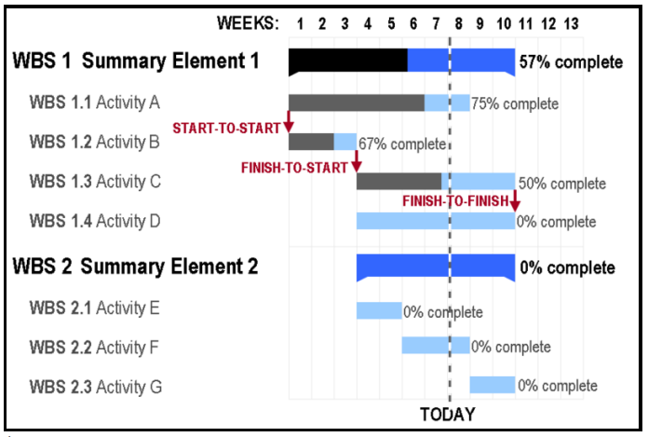

**Useful Language**

When discussing a team project, it is important that we differentiate between factual and personal comments, especially when giving feedback. In addition, in English we tend to be less direct and more polite when we voice our opinion.

Here are some useful phrases which you can use for our log meetings:

|  |  |
| --- | --- |
| **Function** | **Examples** |
| Stating an opinion | * *In my opinion...* * *The way I see it...* * *If you want my honest opinion....* * *According to Lisa...* * *As far as I'm concerned...* * *Personally, I think...* * *If you ask me...* |
| Asking for an opinion | * *What's your idea?* * *What are your thoughts on all of this?* * *How do you feel about that?* * *What do you think?* * *Do you agree?* * *Wouldn't you say?* |
| Expressing agreement | * *I couldn't agree with you more.* * *You're absolutely right.* * *That's exactly how I feel.* * *I'm afraid I agree with James.* * (agree with negative statement) *Me neither.* * *You have a point there (, but...).* * *I agree with you up to a point.* |
| Expressing disagreement | * *Not necessarily.* * *That's not always true.* * *That's not always the case.* * *No, I'm not so sure about that.* * *I'm afraid I disagree.* * *I beg to differ.* * (strong) *I'd say the exact opposite.* * (strong) *I totally disagree.* |
| Clarifying a point | * *What I really mean is...* * *What I’m trying to say is...* * *My point is...* * *What do you mean by that?* * *I’m sorry, what do you mean exactly?* * *Are you saying...?* |
| Interruptions | * *Can I add something here?* * *Is it okay if I jump in for a second?* * *If I might add something...* * *Sorry to interrupt, but...* * (after accidentally interrupting someone) *Sorry, go ahead.* OR *Sorry, you were saying...* * (after being interrupted) *Can I finish first?* |
| Making suggestions | * *Let’s...* * *How about* (noun/verb + *-ing*)*…?* * *Why don’t you/we…?* * *I think you/we should…* * *Why not* (verb + *-ing*)*…?* * *Wouldn’t it be better to…?* |